CREATIVE BRIEF - DRAFT November , 2013

Client | Freedom Swing
Project Name | Winter Swing Dance – A Formal Affair

Situation Overview/Background
Freedom Swing is the big band ensemble of the Mile High Freedom Band. Freedom Swing was formed in part to provide greater community outreach and exposure on behalf of the full band organization, with the goal being that Freedom Swing establishes self-sufficiency and ultimately becomes a revenue generator on behalf of the Mile High Freedom Band organization.

Freedom Swing has performed a number of times for more exclusive events such as the Denver Gay Chamber awards dinner, The Power Party, as well as appearing at both Denver and Boulder Pride. But awareness remains low and the number of performances has been limited.

Freedom Swing embarked on producing its own swing dance events to drive greater awareness and establish a patron base. We expect that hosting a dance will provide a unique point of access for the GLBT community for an accepting environment for couples of any makeup to enjoy the energy and fun of swing dancing, but we also anticipate that the event will provide broader community outreach to those in the Denver swing dance community.

This is the third Freedom Swing dance event and we want to continue to make each event unique and attention grabbing. The dance music will draw upon big band standards that are the foundation of most swing band repertoires and familiar favorites for those who like to swing dance.

Assignment

Create a theme and core visual treatment that quickly communicates an energetic, participatory swing dance.

Pieces to execute:
- Postcard size flyer/Program Ad 4 ¼ X 5 ½ (also for use in electronic email distribution)
- Web site Feature 672 x 378 pixel
- Web site square icon for use on MHFB.org and OutFront email blasts
- Facebook feature – size tbd

Overall Communication Objective

- Quickly communicate the theme of the concert
- Clearly identify date/time/location of the concert
- Build awareness about the concert and encourage attendance
- Clearly identifies Freedom Swing to help build broader awareness
- Set an expectation for the concert experience – this is a dance
- Be visually arresting in a cluttered communications environment
  - Build off of the MHFB design esthetic for continuity
  - Build upon initial graphics done for the save the date (below)
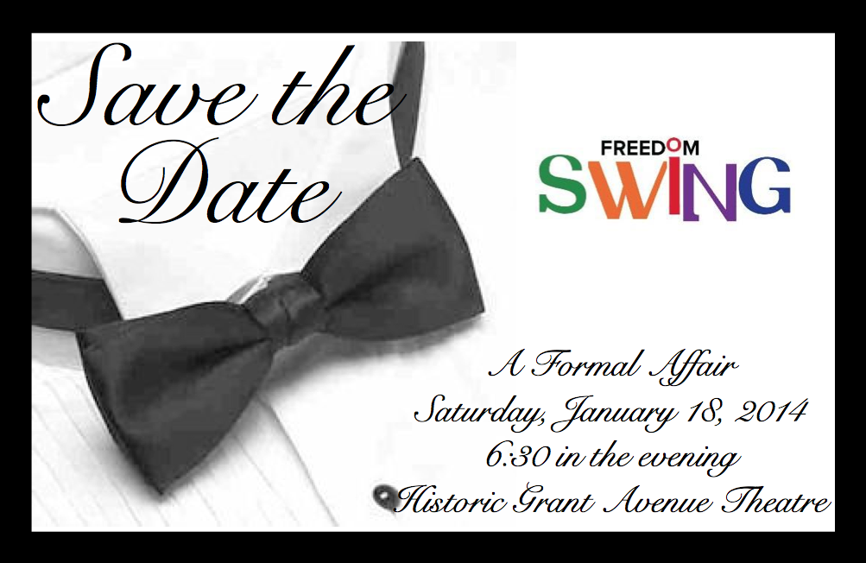

- Identifies the LGBT-friendly nature of the ensemble / event

Target Audience

Band Friends/Family
- Our primary concert attendees are people who have a direct connection to a band member. They come to support us, enjoy our performances, and enjoy watching the musicians do what they love. This is another genre of music that many of our supporters enjoy.
GLBT Community
- We continue to work to build our prominence and visibility among the GLBT community as one of the core performing arts groups that supports the community. We’d love everyone to attend, but if they don’t attend, we want them to know what we’re up to and recognize our contributions to our community.

General Public – Swing Dancers
- There’s a strong swing dance community anxious for live music opportunities to do their thing. We expect we will have a positive draw from this connected group of dancers as we build our reputation.

Desired Brand Image

Freedom Swing is a fun, accessible big band ensemble. The band performs at a high level, and our visual support materials should reflect that as well. Part of the magic of swing is that it’s a two-way give and take with the dancers/ audience with the band. We want our materials to capture that if possible.

Key Message / Program / Personality/Tone

CONCERT THEME
Derek has themed this performance as “A Formal Affair” giving a nod to the big band era and setting a tone for the performance and overall experience.

THE PROGRAM
Freedom Swing will perform 3 sets of big band standards. The space includes a stage and dance floor and we will also have a bar so this will be a social and participatory event. This is not a sit and quietly listen type of concert.

PERSONALITY/TONE/MANNER
- Lively and energetic
- Convey a sense of fun and participation
- Classy – play off the “formal” aspect, but avoid being too stodgy

MANDATORIES
- Use the SCFD logo on the piece (pull from the SCFD.org site)
- Include Historic Grant Avenue logo
- Make sure the Freedom Swing logo is prominent and readable

The Details

DATE: Saturday, January 18, 2014

TIME: 6:30 pm swing dance lessons
7:00 pm performance

WHERE: Historic Grant Avenue Ballroom
216 South Grant Street
Denver, CO 80209

ADMISSION: $10

INFO AVAILABLE AT: mhfb.org

